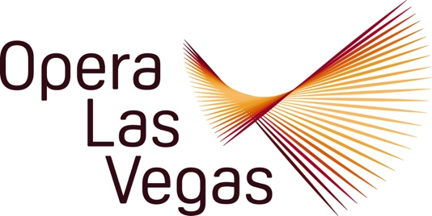

For Immediate Release

Opera Las Vegas Presents “Viva Verdi!” – the Greatest Works of Opera’s
Greatest Composer - on April 6th at Myron’s at The Smith Center

Las Vegas, NV – (March 18, 2025) – Opera Las Vegas (OLV) presents Viva Verdi! – a collection of Giuseppe Verdi’s greatest opera compositions – on April 6th at Myron’s, the intimate venue inside The Smith Center. The evening will feature full-throated solos and ensemble pieces from such acclaimed Verdi scores as Rigoletto, La traviata, Aida, and Il Trovatore.

Viva Verdi! features two singers who are inaugural members of the Christopher and Anita Murray Opera Las Vegas Studio at the University of Nevada, Las Vegas, soprano Claudia Affan and tenor Christian Shelton. Ms. Affan most recently delighted us as Berta in OLV’s production of The Barber of Seville, while Mr. Shelton was lauded for his contributions to the company’s tribute concert, Opera Legends in Black.

They are joined by Christina Mancheni, an OLV audience favorite who is remembered for her stirring portrayal as “Ma” Zegner in the West Coast premiere of Missy Mazzoli and Royce Vavrek’s Proving Up. She shared the stage in that production with Verdi baritone Joseph Lodato, who ably partnered her as “Pa” Zegner. Mr. Lodato appears frequently with the famed Lyric Opera of Chicago.

Mezzo-soprano Stephanie Weiss makes a welcome return to Opera Las Vegas, after having previously enchanted audiences as Suzuki in Madama Butterfly, and as the plucky servant Berta in The Barber of Seville in seasons past. This distinguished quintet of vocalists will be partnered on the keyboard by collaborative pianist, Dennis Doubin, a fixture at Santa Fe Opera, San Francisco Opera, and San Diego Opera, to name but a few of his illustrious companies.

To enhance the presentation, OLV General Director Jim Sohre will narrate the concert, providing context and insights into the program highlights. The selections will be sung in the original Italian, with projected English translations to allow for “instant understanding.” Myron’s menu of “small plates and sweet bites” and an array of beverages will be available to purchase before the show and at intermission, with service paused for the unamplified performance.
Sohre notes: “We did a version of this concert some years ago and the melodic allure of the timeless music coupled with fiery Italianate passion was so well received by a sold-out crowd, that we thought it was time to bring the Master’s music back to Myron’s. We are thrilled that Bruce and Barbara Lee Woollen are generously sponsoring the production.”

More information and tickets are available by visiting operalasvegas.com.

###
MEDIA CONTACT:
Jim Sohre, General Director, Opera Las Vegas
(270) 499-7075
jimsohre@yahoo.com

ABOUT OPERA LAS VEGAS:
The only professional company member of Opera America operating in Nevada, OPERA LAS VEGAS has been promoting and producing operatic performances and concerts in Las Vegas since 1999. Opera Las Vegas is a non-profit organization whose mission is to remain a strong cultural force in the Las Vegas Community by creating unforgettable moments of inspirational artistry and by bringing diverse representation into new explorations of the art of opera. Contact Opera Las Vegas at 702.263.6604 or visit them at operalasvegas.com.

