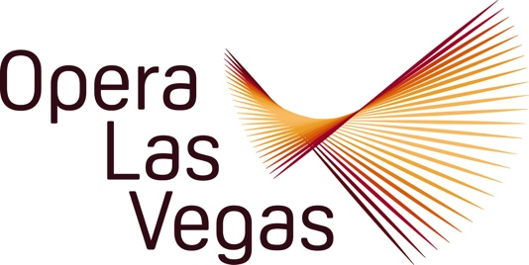

For Immediate Release

Opera Las Vegas Presents “Opera Legends in Black”
Tribute on January 17th at Whitney Library Theatre

Las Vegas, NV – (December 30, 2024) – On the eve of the Dr. Martin Luther King, Jr. Day holiday weekend, Opera Las Vegas will celebrate legendary African American singers and composers with “Opera Legends in Black,” a free tribute concert on Friday, January 17th at 7:00 pm in Whitney Library Theatre.

The 60-minute narrated program will showcase the inspirational international success stories of such heralded singers as Martina Arroyo, Simon Estes, Jessye Norman, Leontyne Price, Shirley Verrett, Marion Anderson, Reri Grist, and William Warfield among others; and will toast composers Florence Price and Scott Joplin.

The varied selections consist of world-famous classical arias and songs ranging from Puccini (Turandot) to Wagner (Tannhäuser), Bizet (Carmen) to Donizetti (The Elixir of Love), with a bit of Broadway thrown into the mix. The program also showcases historically important pieces like Treemonisha and Porgy and Bess.

On hand to raise their voices in joyous celebration are four of Opera Las Vegas’ top tier singers: Sopranos Christina Mancheni, a local favorite for her past stirring OLV performances (Proving Up); and Monica McCullough, an award-winning performer and renowned voice teacher who has often graced these “Legends” programs; tenor Christian Shelton, in his first season as one of artists in the Christopher and Anita Murray Studio at the University of Nevada, Las Vegas; and baritone Jawan Jenkins, a rising star who has performed at Houston Grand Opera, the Glimmerglass Festival and Lyric Opera of Chicago. Katie Leung will provide support on the grand piano.

Audiences can expect to be treated to a fast-paced musical journey which promises to be entertaining, enriching and enlightening. “Opera Legends in Black” will give one performance only on January 17th at 7:00 pm in Whitney Library at 5175 E. Tropicana Avenue. The concert is open to the public free of charge. General seating is available on a first come, first served basis. Find out more about Opera Las Vegas at operalasvegas.

###
MEDIA CONTACT:
Jim Sohre, General Director, Opera Las Vegas
(270) 499-7075
jimsohre@yahoo.com

ABOUT OPERA LAS VEGAS:
The only professional company member of Opera America operating in Nevada, OPERA LAS VEGAS has been promoting and producing operatic performances and concerts in Las Vegas since 1999. Opera Las Vegas is a non-profit organization whose mission is to remain a strong cultural force in the Las Vegas Community by creating unforgettable moments of inspirational artistry and by bringing diverse representation into new explorations of the art of opera. Contact Opera Las Vegas at 702.263.6604 or visit them at operalasvegas.com.

