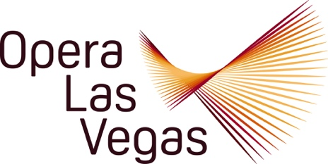

FOR IMMEDIATE RELEASE, PLEASE:

Hero Mine is not only the opening song of Opera Las Vegas’ staged concert, Voices Raised for Vets, it is its over-riding sentiment.

The company is presenting a free 60-minute song-filled presentation on Sunday, 10 November at 3:00 pm in West Las Vegas Library Theatre as a full-throated, gratitude laden honor to those who served and those who serve.

The tuneful selections will run the gamut from light-hearted Broadway fare (I’m in Love With a Soldier Boy, Over There, The Army’s Made a Man Out of Me) and operetta (Stouthearted Men, A Modern Major General, Behold the Sabre of My Father the General, Piff-Paff-Pouf), to selections from operatic “soldiers” in Carmen, The Elixir of Love, and The Daughter of the Regiment.

Irving (God Bless America) Berlin gets his due with a sprightly medley of his World War Two hits, including Gee, I Wish I Was Back in the Army. The many lighthearted moments are punctuated with poignant moments that reflect on the challenges that service members and their families endure to fulfill their duties.

The cast is a Who’s Who of OLV favorites including soprano Athena Mertes (The Ghosts of Gatsby, 27); mezzo-soprano Ashley Stone (Noah’s Flood, Hansel and Gretel); OLV Studio Artists soprano Claudia Affan and tenor Christian Shelton (Opera Uncorked); bass Norman Espinoza (Holiday on Broadway, Letters to Lily), and the company debut of baritone Jawan Jenkins.

The OLV Youth Chorus will chime in with a rousing rendition of the well-known Soldiers Chorus from Gounod’s Faust. Dr. Spencer Baker is the acclaimed pianist for the program. General Director Jim Sohre will provide informative commentary.

Voices Raised for Vets is made possible by generous support from Robert and Shirley Kramer, and Clark County Libraries. The program is suitable for all ages. West Las Vegas Library Theatre,
951 W. Lake Mead Boulevard, 10 November, 3:00 pm, free admission on a first-come, first-served basis. For more information, please visit: www.operalasvegas.com

Opera Las Vegas 10620 Southern Highlands Parkway Suite 110 Las Vegas Nevada 89141
Director@operalasvegas.com PH: (702)-499-7075

