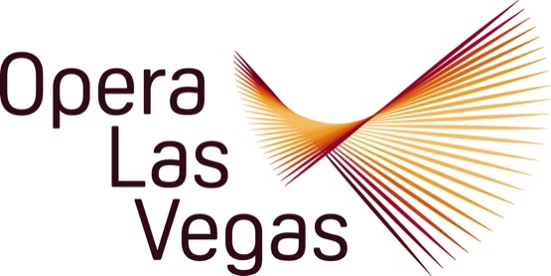

FOR IMMEDIATE RELEASE, PLEASE:

Opera Las Vegas announces the establishment of the Christopher and Anita Murray Opera Las Vegas Studio at the University of Nevada, Las Vegas with the start of its 2024-2025 Twenty-sixth Anniversary season.

The two premiere Studio Artists in this prestigious new initiative are soprano Claudia Affan and tenor Christian Shelton.

Claudia Affan is pursuing a Master of Music in vocal performance at the University of Nevada, Las Vegas (UNLV). She holds her Bachelor of Music in vocal performance from Auburn University, where she studied with Dr. Matthew Hoch. Her operatic roles include Jenny Slade in Roman Fever, The Daughter in Strawberry Fields, Madame Herz in Der Schauspieldirektor, Violetta in La traviata, and Susanna in The Marriage of Figaro, among many others. Ms. Affan has received awards at the state, regional, and national level from the National Association of Teachers of Singing (NATS), the Vann Vocal Institute, the Musical Teachers National Association, and Alabama Federation of Music Clubs. She studies voice with Dr. Linda Lister. She notes that she is “very excited and thrilled to be selected for this landmark new training opportunity with a professional opera company.”

Christian Shelton begins graduate school this semester at UNLV and is dedicated to his studies in Vocal Performance under the guidance of Dr. Alfonse Anderson. His recent achievements include clinching 1st place at the prestigious National Classical Singer competition in 2023 within the Classical University Division. In the same year, he secured the top spot at the local NATS competition, and his success continued into 2024 with another 1st place showing at the Regional NATS competition. Christian just returned from the prestigious training program, American Institute of Musical Studies in Graz, Austria, where he was honored by being selected as one of only eight finalists in the annual Meistersinger Vocal Competition. Christian enthuses that his “passion for vocal excellence and success underscores his commitment to musical excellence.”

General Director Jim Sohre lauds Christopher and Anita Murray, longtime OLV Trustees for their visionary support: “We are so grateful to the Murrays for underwriting this vital new program, one that will not only greatly enhance our mission for making opera accessible to a diverse demographic but will also serve as an important collaboration with the award-winning Opera and Voice program at UNLV.”

The Murrays commented: "We are most pleased that we could play a part in bringing this long dreamt of project into realization, knowing that it promises to be a fruitful collaboration that will enhance Opera Las Vegas programming, all the while supporting UNLV in providing important additional professional training opportunities for the stars of tomorrow."

Dr. Linda Lister, UNLV Opera Program Director will serve as liaison and advisor added: “This partnership between Opera Las Vegas and UNLV Opera brings exciting educational and artistic opportunities to our students and strengthens the community impact of both organizations. The initiative provides a valuable launching pad for UNLV Opera singers, facilitating their transition from pupil to professional.”

Claudia Affan and Christian Shelton made their Studio Artist debuts at Opera Las Vegas’ season opener on 10 September, the mini-gala Opera Uncorked at Monzú Italian Oven + Bar. Joined by nationally known baritone Brian James Myer and collaborative pianist Deborah Gordillo, Opera Uncorked featured drinking songs and party scenes from opera and operetta, Broadway shows, and the pop music canon.

Throughout the season, the pair will appear singly and together in home hosted friend- and fund-raising events; thematic concerts including Voices Raised for Vets, Holiday on Broadway, Opera Legends in Black, and Viva Verdi!; The Barber of Seville; and the spring tour of the young family friendly opera, John Davies’ Pinocchio. As part of their training as Studio Artists, they will receive professional vocal coaching, repertoire development, and high profile performance opportunities throughout the Valley at such renowned venues as Myron’s at The Smith Center.

Sohre added: “We are very excited to welcome two such outstanding performers to the OLV roster as the founding members of the Christopher and Anita Murray Opera Las Vegas Studio at the University of Nevada, Las Vegas. They are certain to add memorable moments to our Twenty-sixth Anniversary schedule, A Season of Smiles.”

Opera Las Vegas
10620 Southern Highlands Parkway, Suite 110
Las Vegas, NV 89141

Tel: (702)-499-7075
Email: Director@operalasvegas.com

