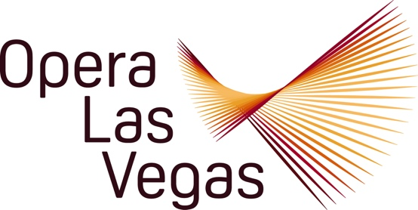

FOR IMMEDIATE RELEASE, PLEASE:

Opera Las Vegas is proud to announce the World Premiere of a brand new comic one act opera, Again and Again and Again, by composer Conrad Cummings and librettist Mark Campbell, on 11, 12, and 13 October at the well-known popular music venue, The Space.

The piece is loosely based on Pierre Corneille’s classic meta-theatrical fantasy L’Illusion Comique (The Comic Illusion) and traces a father’s search for his son across four centuries. You read that right. In this original work, Corneille made use of multiple theatre genres: A prologue is marked by a bucolic pastoral style, which then careens into a unique comedy with a farcical character at its center, finally devolving into a skewed tragicomedy. The Comic Illusion is a summary of a theatrical universe, and Corneille shows his mastery of theatre as a whole. The prolific contemporary librettist, Mark Campbell has used Corneille’s play as basis for inspiration to further skew the wacked out concept by framing it with a contemporary sensibility in Again and Again and Again.

In Campbell’s version we begin in rural France in 1789, when Pridament, nearing the end of his life, visits the cave of the gender fluid sorcerer (sorceress?) Alcandra and asks for help in finding his estranged son Clément who ran away from him ten years before. Alcandra agrees to show Pridament three visions that will explain his son’s whereabouts under the condition that he does not disrupt the visions in any way. Which will be hard, given the goofy visions they prove to be, leap-frogging decades, and then centuries, as the wayward son morphs and reincarnates into a myriad of beings as the dotty old dad follows the sorcerer into ever more inexplicable situations. In an opera about the power of love to transcend time, are father and son finally reunited?

Conrad Cummings is a versatile composer on the faculty of The Juilliard School Extension, who writes operas, instrumental music, and music for amplified instruments and voices. His work is heard in venues from Carnegie Hall and BAM to alternative clubs Poisson Rouge and The Knitting Factory. Opera productions range from the three-act, grand opera exploration of the Vietnam War Tonkin, to the three-week Off-Broadway run of the electoral campaign opera Photo-Op. The Golden Gate, with Vikram Seth, was honored among Opera News Best Operas of the 21st Century.

Librettist/Lyricist Mark Campbell’s Pulitzer Prize and Grammy Award-winning works are among the most successful in the contemporary opera canon. Mark has written 40 opera librettos, lyrics for 7 musicals, text for 9 song cycles, and 5 oratorios. His works include Silent Night, The Shining, The (R)evolution of Steve Jobs, As One, Elizabeth Cree, Sanctuary Road, Stonewall, Later the Same Evening, A Thousand Acres, Edward Tulane, A Nation of Others, and Songs from an Unmade Bed. In 2020, he created and funded the first ever award for opera librettists: the annual Campbell Opera Librettist Prize.

The cast will feature the return of some OLV favorite performers: André Chiang (Behold the Man, La bohème), Athena Mertes (The Ghosts of Gatsby, Behold the Man), Erin Gonzalez (A Capacity for Evil, Trouble in Tahiti), and Kayla Wilkens (Proving Up, The Ghosts of Gatsby). They are joined by OLV debut performers of national acclaim: Tenor Xavier Prado (Sarasota Opera, Opera Santa Barbara), baritone Justin Burgess (Washington National Opera, Glimmerglass Opera), and bass-baritone Peter Barber (Arizona Opera, Academy of Vocal Arts).

Veteran OLV Music Director and Principal Conductor Joshua Horsch (La bohème, La traviata, Behold the Man) will be on the podium, leading members of the Las Vegas Philharmonic in the composer’s freshly crafted chamber orchestration.
Marc Callahan, remembered for his work directing D.J. Sparr and Mark Campbell’s Approaching Ali, will be back to stage the premiere in one of OLV patrons’ favorite locations, the intimate venue, The Space, at 3460 Cavaretta Court.

The World Premiere of Again and Again and Again will not only be preceded by Mssrs. Cummings and Campbell meeting with music students at the University of Nevada, Las Vegas in the days prior, but the creators will also be in attendance at opening night to participate in a post-show Q&A session. This production is part of OLV’s National Endowment for the Arts award-winning Living Composers and Librettists Initiative.

For more information and tickets to Again and Again and Again at The Space on 11 and 12 October at 7:30 pm; and 13 October at 6:00 pm, please visit: www.operalasvegas.com

Opera Las Vegas 10620 Southern Highlands Parkway Suite 110 – 405 Las Vegas Nevada 89141
Telephone: (702)-499-7075 Email: Director@operalasvegas.com

