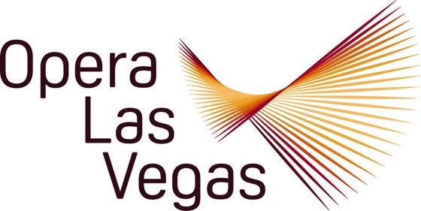

FOR IMMEDIATE RELEASE, PLEASE:

Opera Las Vegas announces its 2024-2025 Twenty-sixth Anniversary schedule, billed as a Season of Smiles.

General Director Jim Sohre says: “Given the occasional turbulence of the times, we figured everyone would welcome a good laugh, and with a slate of comic operas and uplifting events, we hope to play a part in filling that need. Spoiler Alert: Atypically for an opera season, no one dies!”

The joyous singing begins on 10 September with Opera Uncorked, a themed concert with dinner at Monzú Italian Oven + Bar, featuring the inaugural Studio Artists of the Christopher and Anita Murray Opera Las Vegas Studio at the University of Nevada, Las Vegas.

The first staged production of the season is the World Premiere of Conrad Cummings and Mark Campbell’s new comic one act opera, Again and Again and Again. Based loosely on Corneille’s L’Illusion Comique, this wacked-out tale follows an old Frenchman who employs a sorceress to track down his estranged son, who keeps reincarnating across centuries. Performances are at The Space on 11, 12, and 13 October.

Two of OLV’s most popular free annual events make a welcome return: Voices Raised for Vets, a staged concert honoring those who served and those who serve, is at the West Las Vegas Library on 10 November; and Holiday on Broadway, featuring holiday and seasonal tunes from the Great White Way is at the Windmill Library on 14 December.

The new year brings another once-each-season treat, Opera Legends in Black, a tribute concert honoring the accomplishments of African American singers and composers with vocal selections and narration of their compelling personal journeys to greatness in spite of societal challenges. The free performance opens on the eve of the Martin Luther King, Jr. holiday weekend, 17 January 2025 at Whitney Library.

One of the world’s favorite comedies, Rossini’s The Barber of Seville will take the stage of the Horn Theatre at the College of Southern Nevada for two performances only, on 21 and 23 February 2025, updated to a merry Hollywood milieu, where Figaro is hairdresser to the stars. The Horn is also host to the second annual Celebración Latina on 16 March featuring CSN’s award-winning Mariachi Plata, zarzuela (Spanish operetta), and tributes to world- famous Hispanic opera stars.

Opera Las Vegas will return to Myron’s at The Smith Center for the seventh time for a healthy dose of the classics when Viva Verdi! is presented on 6 April 2025. Expect to hear full throated solos and ensembles from such acclaimed scores as Rigoletto, La traviata, Il trovatore, and other masterworks, while enjoying the classy supper club atmosphere of the intimate Art Deco venue.

May 2025 will bring the annual young family friendly tour of the fairy tale “opera,” Pinocchio, as adapted by John Davies from music of Offenbach, Mozart, Donizetti, Pergolesi, and yes, even Verdi. Up to six performances are being finalized at diverse demographics in the city.

For a grand finale, Opera Las Vegas will collaborate for the first time with L.A.’s Pacific Opera Project with its first ever presentation of a Gilbert and Sullivan operetta, H.M.S. Pinafore. This rollicking G&S staple will be on stage at the Judy Bayley Theatre, University of Nevada, Las Vegas for two outings on 6 and 8 June 2025.

With this tuneful and varied Season of Smiles, Opera Las Vegas aspires to bring a smile to your face, a spring to your step, and a song to your heart. Learn more about the 2024-2025 line-up by visiting: www.operalasvegas.com

